LAB # 01

Objective: To become familiar with socket programming

1.Modify the sample code so that the sender uses the same socket to send the same message to two different receivers. Start the two receivers first, then the sender. Does each receiver receive the message? Capture the code and output. Describe the outcome.

Sender.java

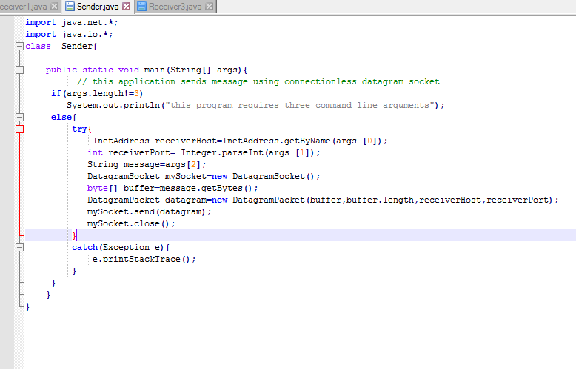

Receiver1 .java

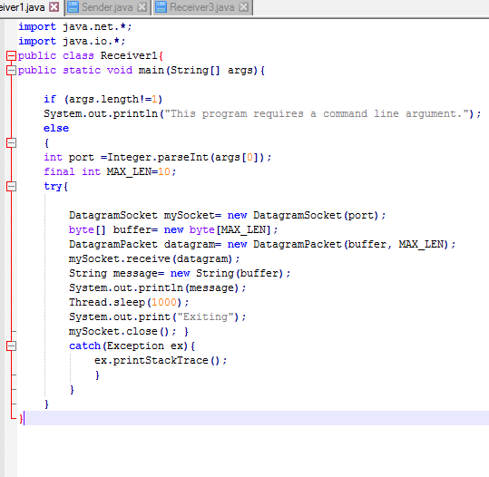

Receiver 2.java

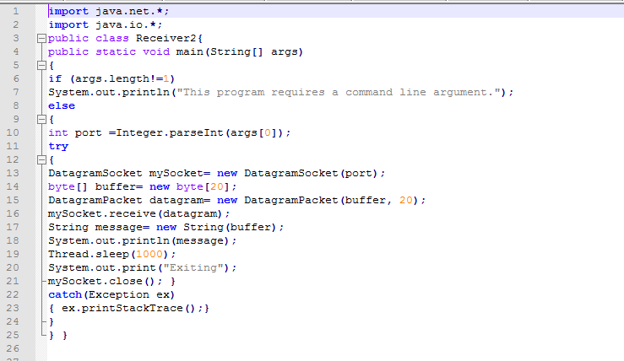

output

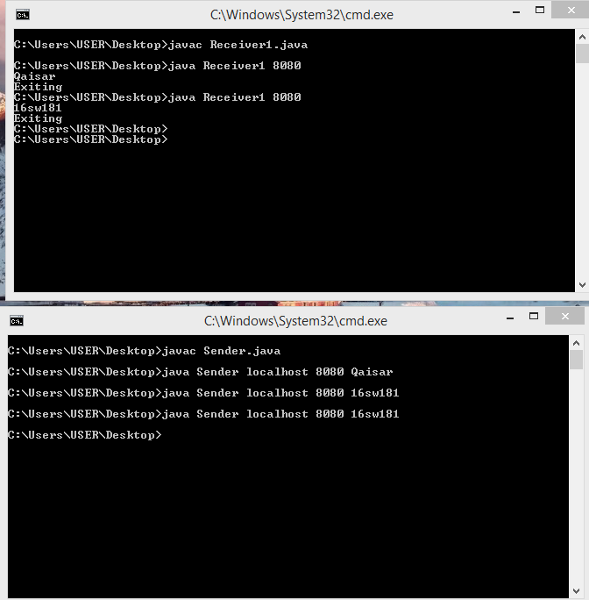

2. Modify the sample code so that the receiver loops five times to repeatedly receive then display the data received. Recompile. Then  
i. start the receiver  
ii. Execute the sender, sending a message “message1”, and  
iii. In another window, start another instance of the sender, sending a message “message2”. Does the receiver receive both the messages? Capture the code and output.

Receiver3.java

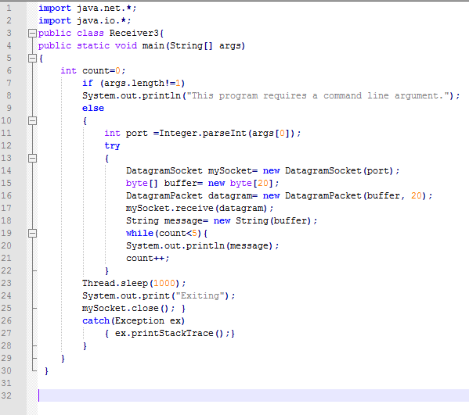

Sender.java

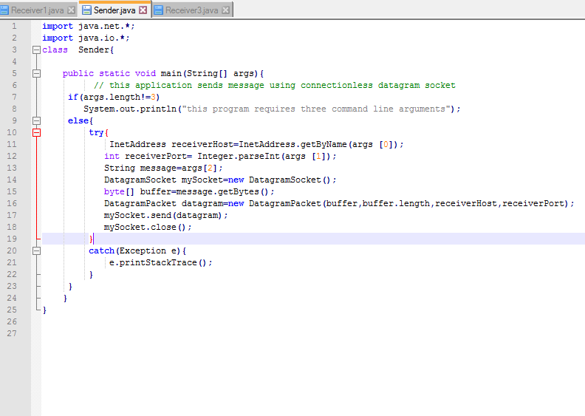

OUTPUT:

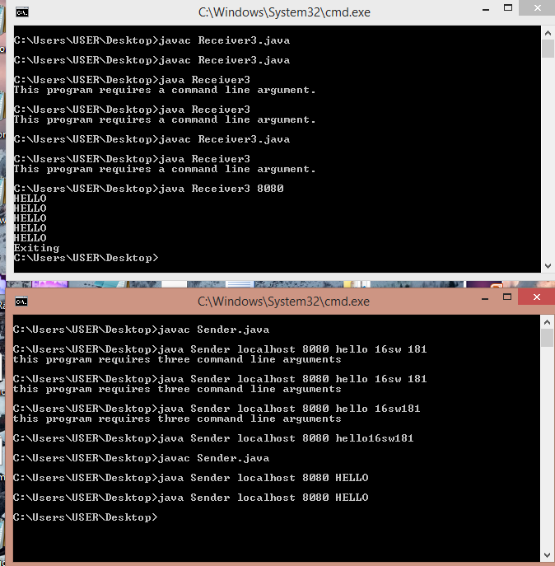.

3. Modify the sample code to cater to a two way communication i.e. Sender sends a message to the Receiver, the Receiver receives the message and sends a reply to the Sender in return.

ChatClient.java

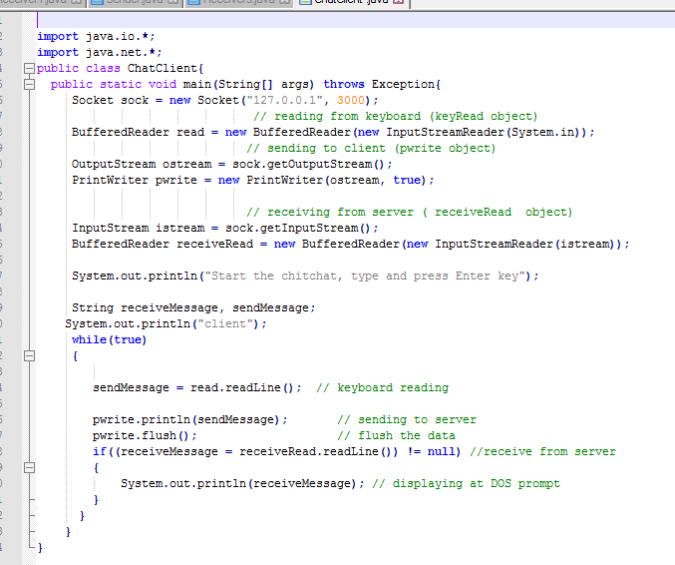

ChatServer.java

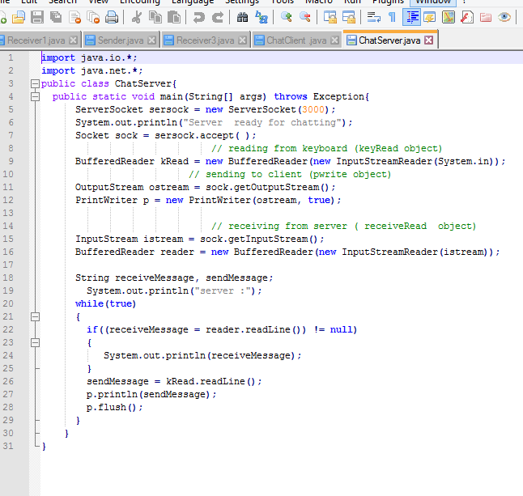

Output:

